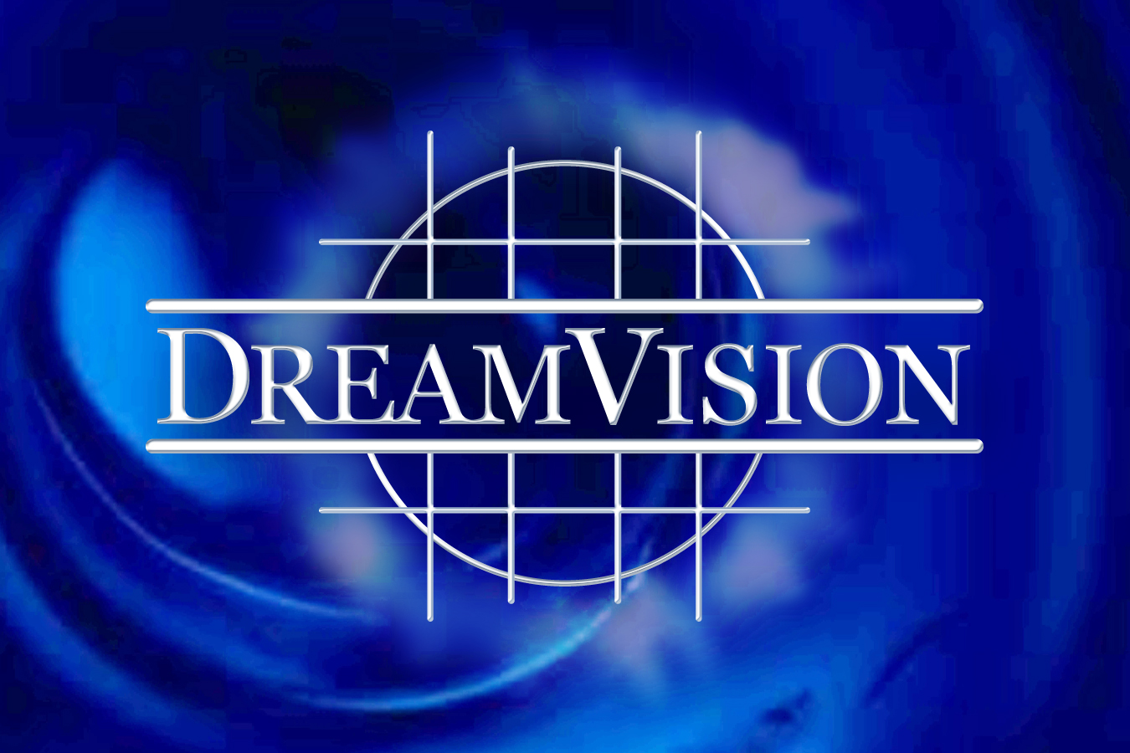

FOR IMMEDIATE RELEASE - February 21, 2010

LAS VEGAS, NV – Dream Vision Studios, a fully operational movie production studio and event venue, has expanded into a new location and is creating the first studio lot in the state of Nevada.
The new building, located just west of the Las Vegas strip at 4544 West Russell Road, is a Harsch Investment Property that has an 11,000 square foot stage and event venue and another 5,000 square feet of production offices. Harsch Investment Properties is working to assist Dream Vision in creating a state of the art studio lot at this location. Dream Vision Studios is the centerpiece of a multifaceted studio that houses multiple on-property vendors including 4Wall Entertainment, Airstar America, JR Lighting, Dolphin Dreamtime Entertainment, Gecko Signs, Panavision and Star Power Generators. Some of these vendors will be making Southern Nevada and the Dream Vision Studio Lot their new home. Dream Vision is dedicated to bringing other film and production related companies into the state which will not only boost the local economy but also create much needed jobs for Nevada.
In addition to the external vendors, Dream Vision provides its own 14 internal divisions: art, camera, catering/craft services, costuming, hair and make-up, lighting and AV, props, rentals, set construction, set design, stunts, VIP services/concierge, wardrobe and the newest division, events.
Whether it is filming a commercial for vitamin water, creating a prop for the television show Let’s Make a Deal, setting up a photo shoot for Criss Angel’s Mind Freak, or creating your own personal wonderland event, Dream Vision studios continues to deliver a product that exceeds the expectations and the imagination of the client.

About Dream Vision Studios:
Dream Vision Studios, a ten year resident of Las Vegas is owned and operated by Phyllis Carreon-Taie, a well-known, well-respected member of the film community and founder of the Women in Film chapter in Las Vegas. And Shawn Lane, owner and founder of Cheyenne Marketing, a PR and Marketing company that has provided Las Vegas with movie premieres and high end events for over fifteen years.
Carreon-Taie and Lane are excited to move forward with this ambitious endeavor and also remain dedicated to nurturing the future of film through state of the art technology and their ongoing educational programs.
For more information or to book the studio please contact Dream Vision Studios (702) 448-1600 or info@Dream Visionstudios.us

